What is Calm Club ? 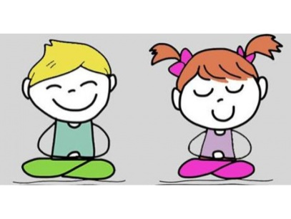

Calm Club is a weekly session run by our ELSA in which we learn ways to develop our own self awareness and begin to understand the importance of looking after our emotional wellbeing.

Who is our ELSA?

The ELSA at Chalk Ridge Primary School is :

Mrs McDermott

Please feel free to contact Mrs McDermott or your child’s teacher if you have any questions.

Calm

Club

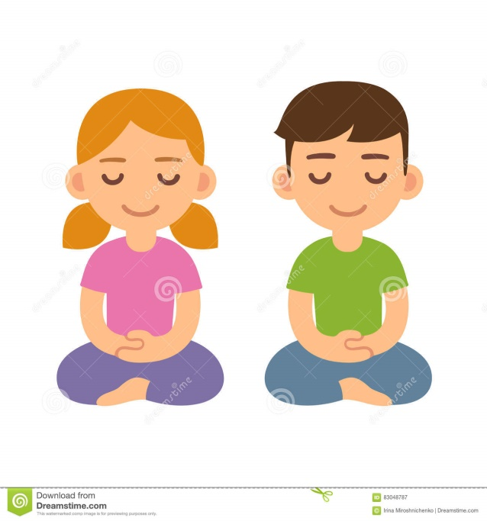

What happens in a Calm Club session?

Sessions are run each term and are held one afternoon a week and last for around 30 minutes. Classes are in groups of 8-10 children.

Breathing techniques, Mindfulness, yoga and relaxation are all used to build calming strategies to help in everyday situations.

“I use some of the breathing to calm me down when I am worried or angry” ……Y5

“It has shown me how to relax even though I’m angry or upset”…… Y4

“I’ve learnt to calm down in different ways”……Y3

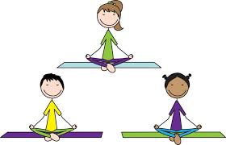

How does this help?

Children learn how to be

Resilient

Focused

Calm

Confident